**Screenshots_for_Retrieving_the_Product_Details_Using_the_Product _ID**

**1. Product_Found**

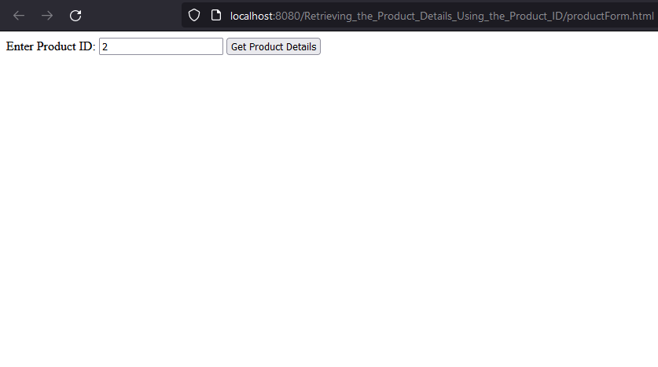

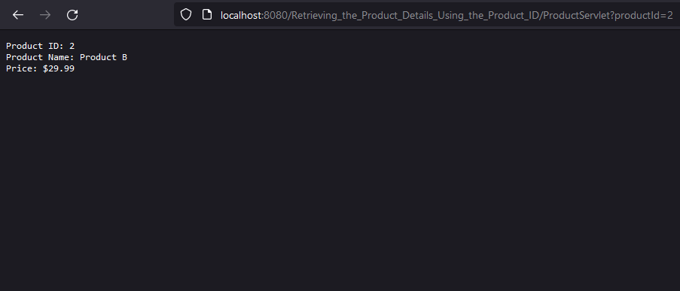

**2.Product not Found**

